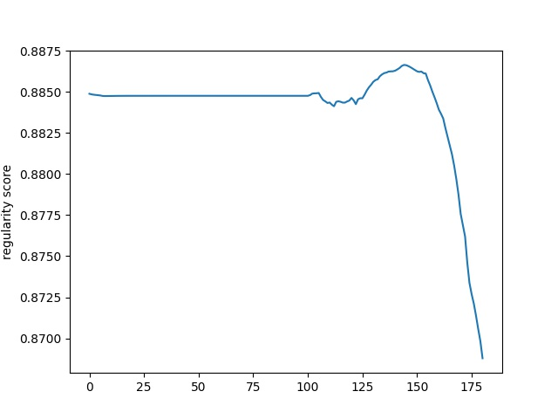

0.8875

0.8850 1

0.8825 1

8 0.8800 -

regularity score

0.8775 1

Фо.8750 -

0.8725 -

0.8700

o

25

50

*75*

100

125

150

175